# Hexagonal Architecture

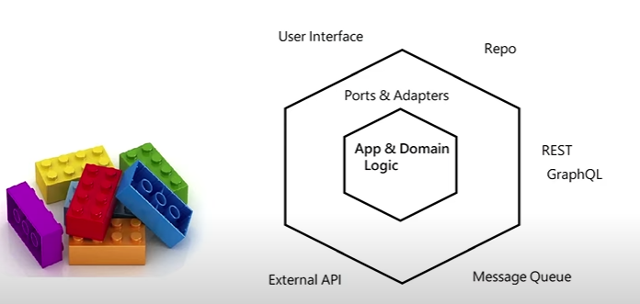

# Set & Run

* set URL_DB=redis
* set REDIS_URL=redis://localhost:6379
* go run main.go